How to Create A Page Selector (Similar to Pretty-) Tracker

This document describes how to create a “page tracker” using the “tracker” feature’s “page selector” field type. The steps on the following pages are very similar to what it takes to create a pretty tracker.

This tutorial was done using TikiWiki Release 3.0, using the “Tikipedia” theme. The current Tikipedia theme has not yet been updated for use with TikiWiki 3.0, so your results may differ from those described here.

A page selector field looks like a normal text box. The text you type into a page selctor field becomes the name of a newly created wiki page.

If the text you type in the page selector field matches the name of an existing wiki page that was created using the page selector field, then you can add or modify the page using the tracker (#1 below) or wiki-page with {TRACKER} plugin (#3 below) interfaces.

If, however, the text you type in the page selector field matches the name of a wiki page that was NOT created using the page selector tracker, then some strange results occur. In this case, the tracker item is created in the page selector tracker, and it indicates that the item is associated with the named wiki page. The wiki page in question, however, will NOT contain any of the data that occurs within that tracker item. This is probably a bug that needs to be addressed, or else is connected to the use of the “Tikipedia” theme.
A Better Page Selector Field?

It is the author’s opinion that the page selector tracker field should probably be something more like the “drop down with other textfield” control.

In this way, the drop-down part of the control could be populated with the names of existing wiki pages [those pages created using the page selector tracker (?)], while the accompanying textfield would serve to create new wiki-page names.

Such a drop-down list might become unwieldly if the number of wiki pages created through the page selector tracker become very large.

Figure 1-A: Four Things Needed to Create a Pretty Tracker (#2 is optional)

TRACKER “Form”

Page Selector:

Text Box:

Text Area:
My Page Title
My text box content
My text area content.
1
Wiki page to display Tracker item

My Page Title

My text box content

My text area content
Underneath, the Wiki page has TRACKERLIST plugin

TRACKERLIST(
trackerId=<numeric ID of the page-selector tracker>,
fields=<numeric fieldId>:<numeric fieldId>,
view=page,
max=-1,
wiki=pagetracker tpl)}
<some optional text>
{TRACKERLIST}

Wiki page as template file for the display page

{$f_##}

{$f_##}

{$f_##}

64
43
Underneath, the Wiki page has TRACKER plugin

{TRACKER
(trackerId=<numeric id of your tracker>,
fields=<field_id>:<field_id>:<field_id>,
view=page)}
<some optional text>
{TRACKER}

Wiki page as Tracker “form”

Page Selector:

Text Box:

Text Area:
My Page Title
My text area content.
My text box content
32
{TRACKERLIST(
trackerId=>#,
fields=>#:#:#,
max=>-1)}{TRACKERLIST}
Wiki page
232

Step – 1: Create a Tracker Containing a “Page Selector” Field
(See #1 in Figure 1-A)

1-A: In your web browser, navigate to…

“http://<your server name>/tiki/tiki-admin_trackers.php”

1-B: Choose the “Create Tracker” tab [or option] and you should see a form that appears similar to Figure 1-B [remember, I am using the “Tikipedia” theme and your Tiki’s tracker-creating form may look somewhat different].

Figure 1-B: Creating a Tracker

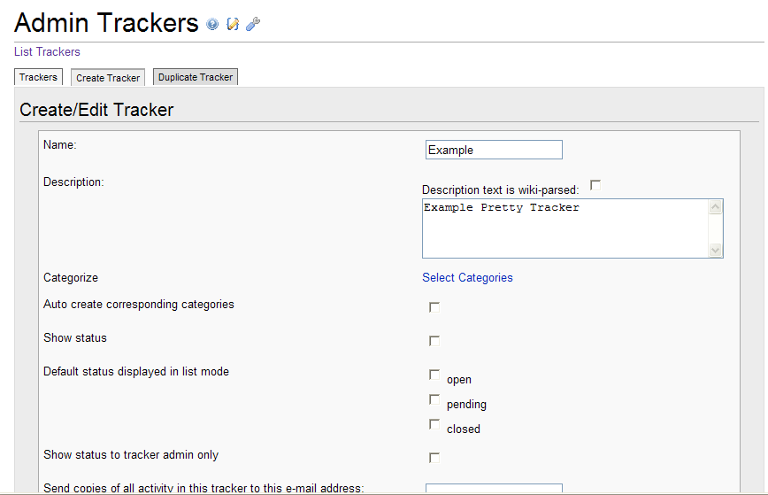

1-C: Give the tracker a name and description, such as the one depicted in Figure 1-B.

Figure 1-C: Select the appropriate configuration choices for your tracker

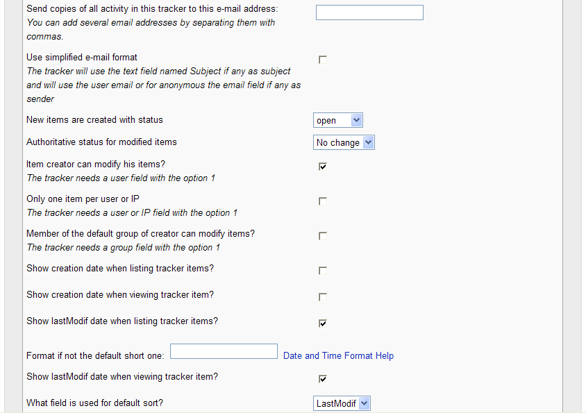

1-D: Save the tracker

Figure 1-D: Click the “Save” button to create the tracker
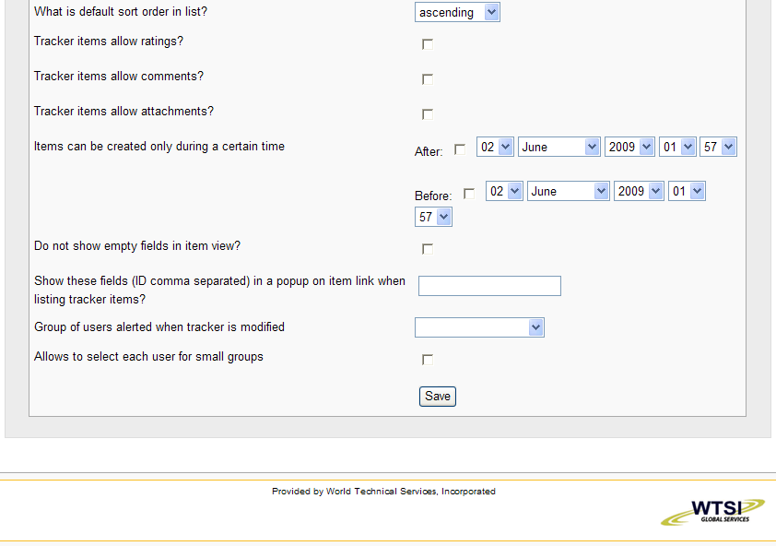

1-E: Verify that the tracker has been created and the fields can now be edited

Figure 1-E: After saving the tracker

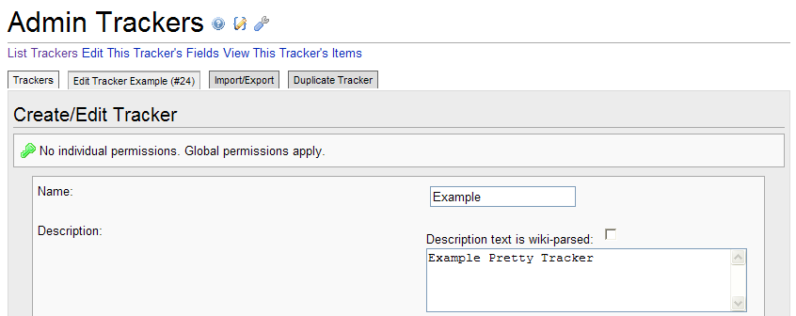

1-F: Add a “page selector” field to your tracker

http://<your server name>/tiki/tiki-dmin_tracker_fields.php?trackerId=24
and add a page selector field with the parameter list defined as “1, 0, display example tracker”. The “display example tracker” indicates the name of the wiki page (see Step 4) that will contain the {TRACKERLIST} wiki-plugin to display your “Example” tracker.

Figure 1-F: Adding a Page Selector Field to your Tracker

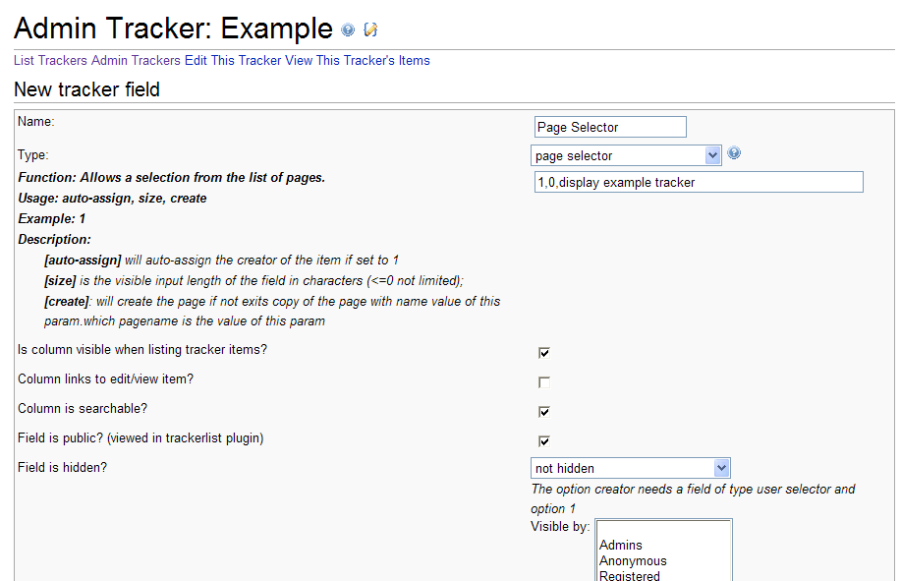
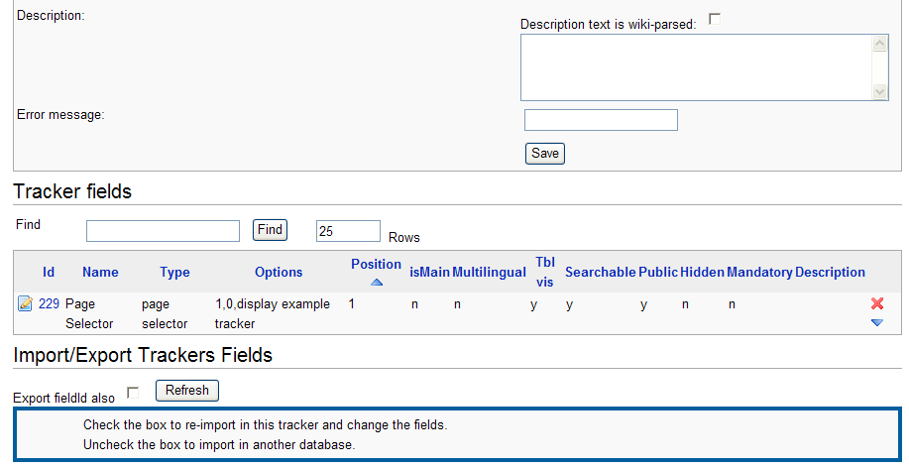
The third parameter listed in this text box (i.e. “display example tracker” will be the name of the Wiki page to be created in Step 4.

1-G: Add two more fields to the “Example” tracker

Figure 1-G: Adding a Textfield to Your Tracker

Create a text field named “Text Box” and set the parameters to “0,30,,,80”.
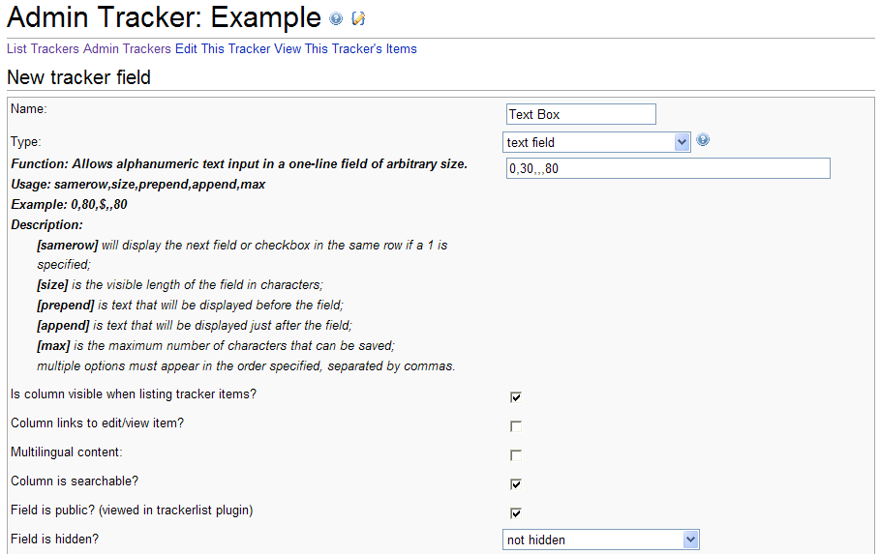
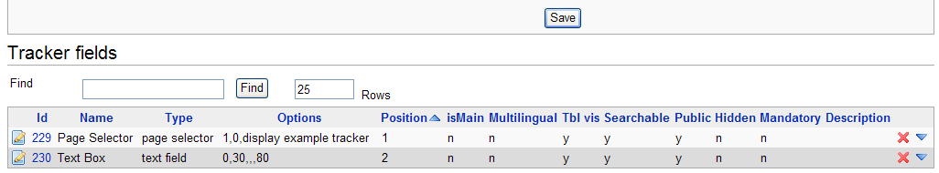

Upon saving the new field you should see the following entries at the bottom of the “Admin Tracker” page…

1-H: Add a text area field to your tracker

Figure 1-H: Adding a Text Area Field

Create a text area field with the parameters defined as, “1,50,10,500,15,80”. The meaning of each parameter in this list is described in the table below the screenshot.

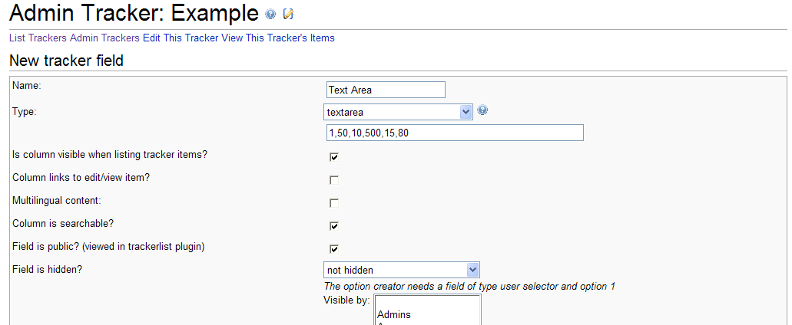

Note: The parameter information is usually included in the Admin Tracker form, but seems to be missing (for the text area field choice) in the initial release of TikiWiki 3.0.

Parameters | type | description | default | version
quicktags | 1 or 0 | to see the quicktags zone(1 = to see them) | 0
width | numeric | number of characters(0 = browser default) | 50
height | numeric | number of lines(0 = browser default) | 4
max | numeric | maximum number of characters that can be saved
listmax | numeric | maximum number of characters that are displayed in list mode
wordmax | numeric | ifnot 0 display the word count, if > 0, javascript alert if word count exceeds the value | 0 | tw>=1.10
Table 1-H: Parameters for a text area field (missing from tracker form in Tiki 3.0)

Figure 1-H1: Your tracker fields should now be defined as shown below…
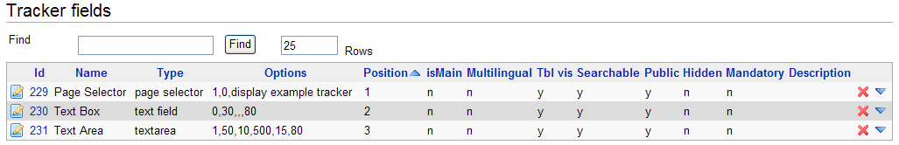

1-I: Verify that your newly created tracker displays these fields to your liking.

Navigate to:

http://<your server name>/tiki/tiki-view_tracker.php?trackerId=<your trackerId number>

And see if the three fields you created in the Example tracker appear as they should.

Figure 1-I: The completed Example tracker has three fields

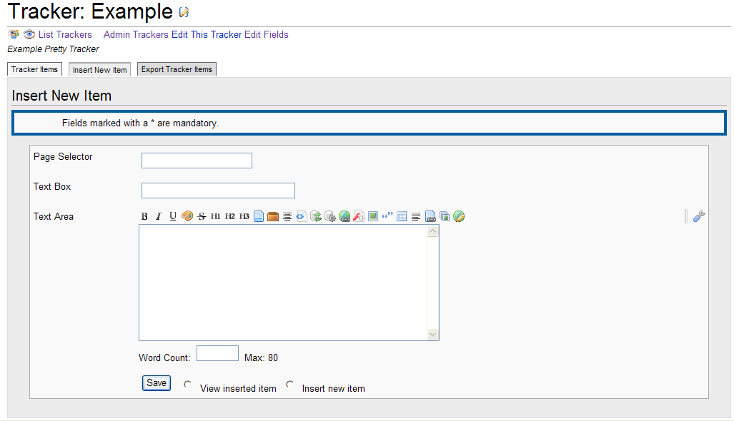
This tracker has the three fields that were created in Steps 1-(A-H).

OPTIONAL
Step 2: Create a Wiki Page to Display All the Items in Your New Tracker
(See #2 in Figure 1A)

This step is optional, but helps in verifying that the items you enter through your wiki-based tracker interface are actually saved to the tracker. The other option is to include some optional text along with the {TRACKER} plugin (See Step 3), which only displays this text as a message after you have clicked the “Save” button on your tracker form.

Use the “quick edit a wiki page” module to create a wiki page named “All Example Items”. This page will be used to display the results of what you enter through the wiki-based input form that you are about to create in Step 3.

2-A,B: Create a Wiki Page and Include a Simple {TRACKERLIST} Plugin

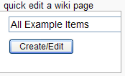
Figure 2-A: Create a Wiki Page

Figure 2-B: Enter the “{TRACKERLIST}” plugin text in the new Wiki Page.

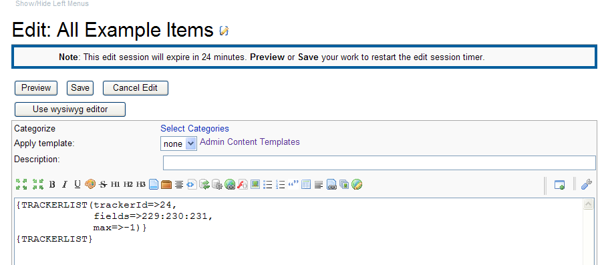
Note: The trackerID (“24”) listed here, matches what was created above, as do the fieldId’s (229,230,231).

The ID numbers in your own “Example” tracker will most likely differ from these ID numbers.

Step – 3: Create a Wiki Page Containing the {TRACKER} Plugin
(See #3 Figure 1-A)

3-A: Using the “quick edit a wiki page” module, enter the text “Add New Example Item” in the text box and click the “Create/Edit” button…

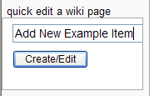
Figure 3-A: Create a New Wiki Page

3-B: In the text field provided, enter the text that defines the {TRACKER} plugin…
{TRACKER(trackerId=24,
fields=229:230:231,
view=page,
url=>"http://<your server name>/tiki/tiki-index.php?page=All+Example+Items")}
{TRACKER}

Figure 3-B: The “Add New Example Item” Wiki Page with {TRACKER} Plugin

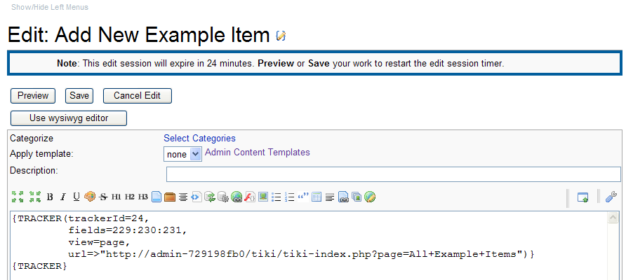
Note: The server name should reflect your server’s name (such as “localhost” if on a development box) and the tracker and field ID numbers should match what you created in your own TikiWiki tracker.

3-C: Upon saving the Wiki page that contains the {TRACKER} plugin, you should see the tracker fields appear in the wiki page, along with a “Save” button.

Figure 3-C: The Completed TRACKER form as displayed in the Wiki Page

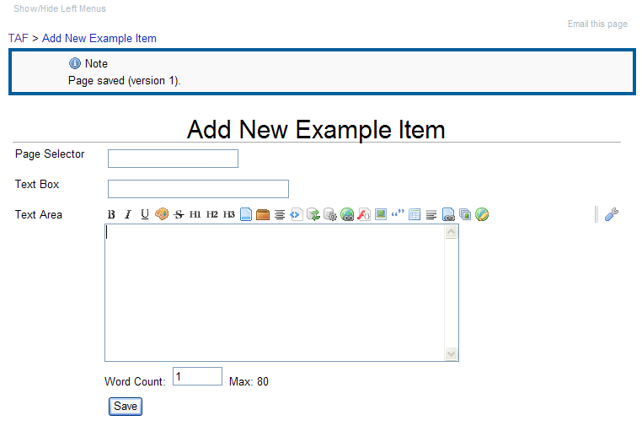
This Wiki page now displays the three tracker fields that were created in Step-1 (A-G).

Step – 4: Create a Wiki Page Containing the {TRACKERLIST} plugin
to display each item you enter using the “Add New Example Item”
Page. (See #4 Figure 1-A)

4-A: Create a Wiki Page titled “display example tracker”

Figure 4-A: Creating a Wiki Page Using the “quick edit a wiki page” Module
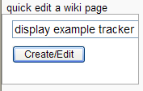
Note: This page must be name
exactly the same as the third
parameter in Figure 1-F
(i.e. “display example tracker”)

Note: All these parameters must be present. The tracker and field ID numbers should match those in your own TikiWiki.

The “wiki” parameter names a yet-to-be created (Step 5) wiki page (exampletracker tpl) that will act as a template (tpl) file for displaying the output.
4-B: Include this {TRACKERLIST} text…

{TRACKERLIST(trackerId=24,
fields=229:230:231,
view=page,
max=-1,
wiki=exampletracker tpl)}
{TRACKERLIST}

Figure 4-B: {TRACKERLIST} Plugin in Wiki Page
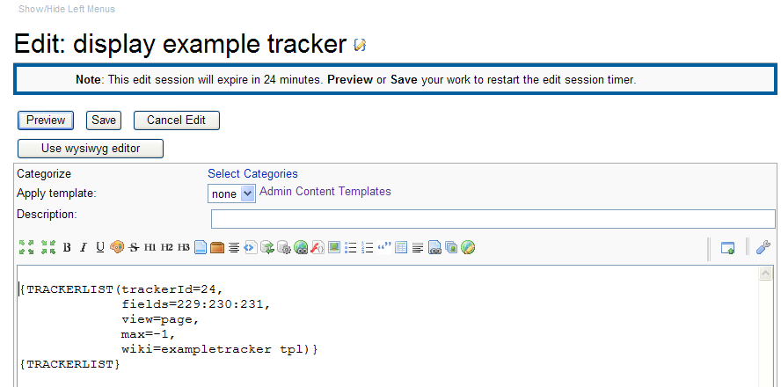

Once you click the “Save” button, the “display example tracker” page that displays will not look very impressive (Figure 4-C). You will need to create the “exampletracker tpl” template page AND set the appropriate permissions on it (Step 5), before your page selector tracker begins to look like something special.

Figure 4-C: The “display example tracker” wiki page displayed after saving it
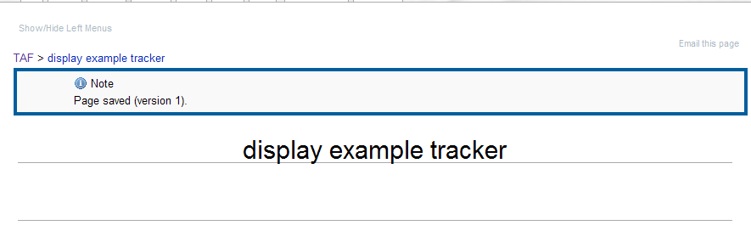

Step 5: Create A Wiki Page to Act as a Template

5-A: Create the “exampletracker tpl” page to act as a template

Figure 5-A: Creating a Wiki Page Using the “quick edit a wiki page” Module

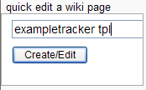
Note: NOT “exampletracker.tpl” but “exampletracker tpl” with a space
(not a dot “.”) between “exampletracker” and “tpl”.

In the wiki page editor, add references for you tracker field ID numbers. The references will be in the form “{$f_<filed ID number>}” (e.g. {$f_230}). You may place these field references anywhere you want in the wiki page, and include other markup around them. If you are using the WYSIWYG editor, you can easily create fancy formats.

5-B: Edit the “exampletracker tpl” file to include your tracker field references

Figure 5-B: Template with Tracker Field References and Markup
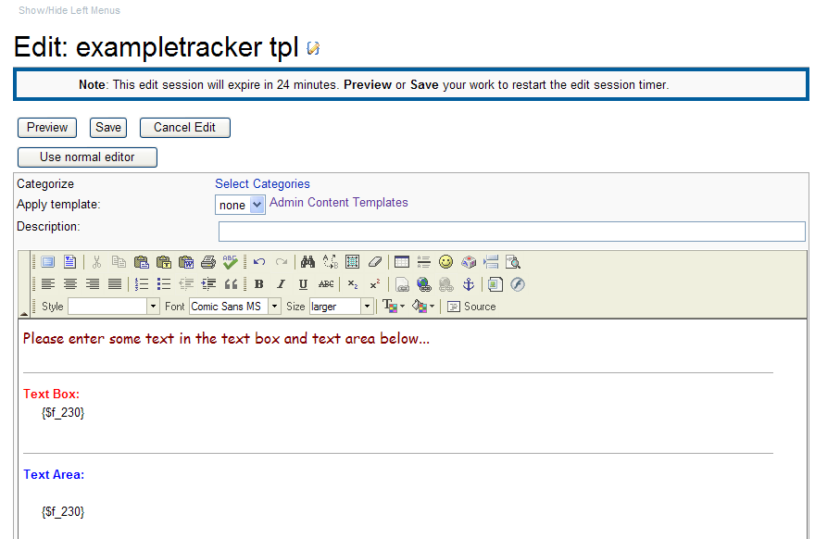
5-C: Save your template page

Figure 5-C: The Saved Template Looks Like a Normal Wiki Page - WYSIWYG

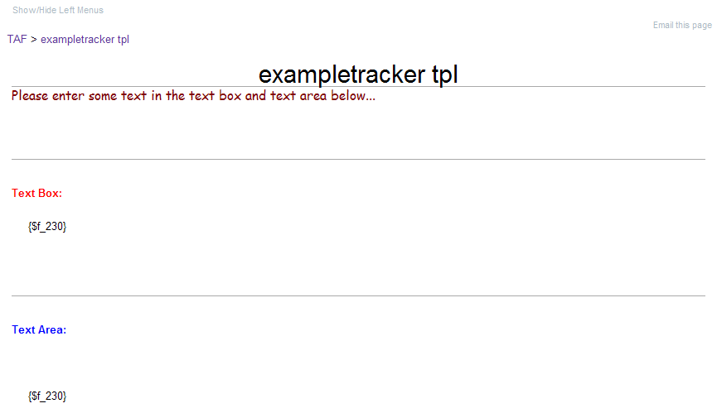
Note: the saved version of your “tpl” page does not look much different than it did in the editor window.

5-D: Edit the Permissions on your “exampletracker tpl” file

Navigate to “http://<your server name>/tiki/tiki-listpages.php” and locate your “exampletracker tpl” page in the list. Click on the icon shaped like a key to navigate to the permissions page.

Figure 5-D: Finding Your Wiki Page Using “tiki-listpages.php”

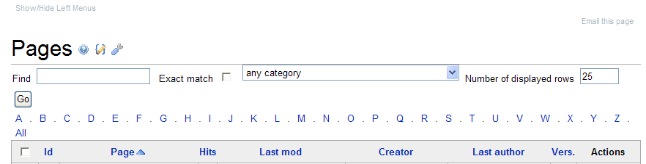

5-E: Select the “Edit Permissions” tab [or option]

Figure 5-E: View Permissions and Edit Permissions Tabs
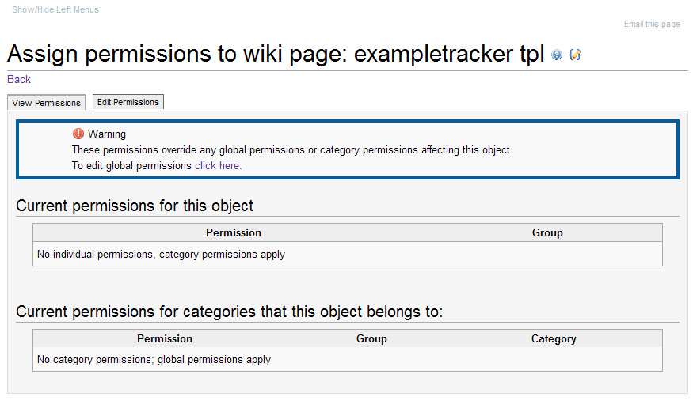

5-F: Locate the “Permissions” and “Groups” columns on the “Edit Permissions” page.

Figure 5-F: The “Permissions” and “Groups” Columns You Need to Modify

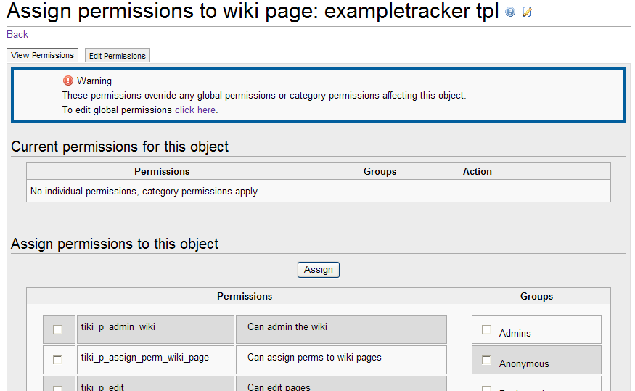
5-G: Under “Permissions”, check “tiki_p_use_as_template”. Under “Groups”, choose “Anonymous” and then click the “Assign” button at the bottom of the page.

Figure 5-G: Appropriate Permission and Group Selection for the Template Page

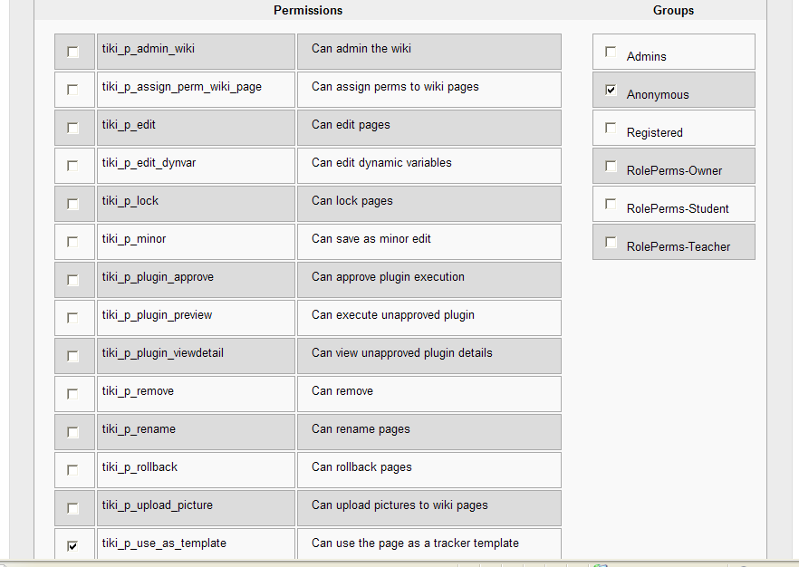

5-H: Verify that the permissions have been applied

Figure 5-H: The Edited Permissions Page

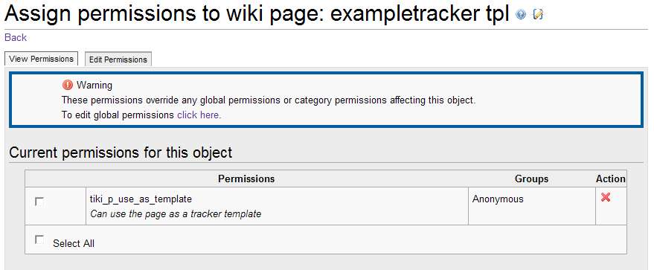

Step – 6: Verify that your Page Selector Tracker Works

Naviage back to your “Add New Example Item” page that you created in Step 3, by entering the following in your browser’s address field:

http://<your server name>/tiki/tiki-index.php?page=Add+New+Example+Item

6-A: Enter Some Text in the Form Fields

Figure 6-A: Filling in Your Page Selector Tracker’s Wiki-Form

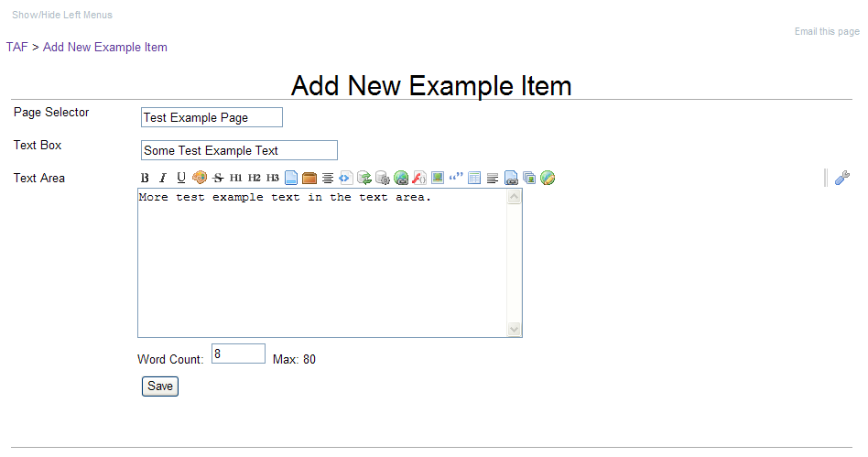
Enter some text in your form fields and click the “Save” button.

6-B: You should see your “All Example Items” page appear, listing your newly created “Test Example Page”…

Figure 6-B: All Example Items Displaying the Newly Created “Test Example Page”

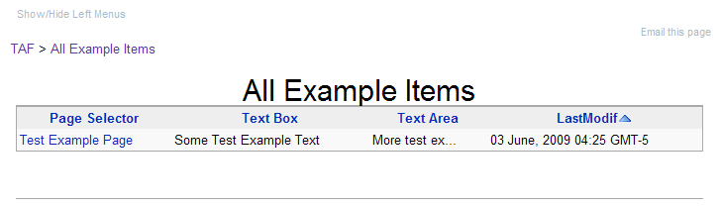
6-C: Click the “Test Example Page” hyperlink to view your wiki page

Figure 6-C: The “All Example Items” Page Created in Step 2

Figure 6-D: The Wiki Page Created Using Your Page Selector Tracker
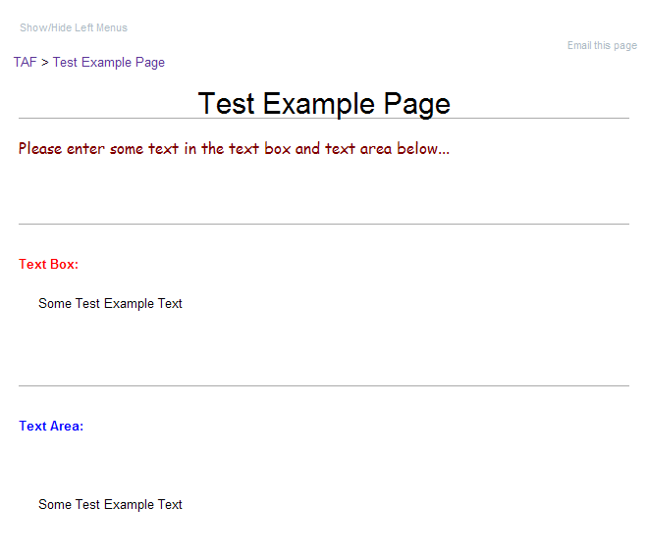
Note: This wiki page has the layout that was defined created in the “exampletracker tpl” wiki page.

6-E: If you place the “Test Example Page” in edit mode, here’s what you will see.

Figure 6-E: What’s Behind Your Newly-Created Wiki Page…

